CS 4372.501 - Assignment 2
Anurag Nagar - Fall 2025
Titanic Survival Prediction
Student: Vaishnavi Pasumarthi, Akshay Nagarajan
NetID: VXP210093, AHN210000
Due Date: October 10, 2025

Project Goals
This project trains and compares four classification methods on the Titanic dataset: Decision Tree, Random Forest, AdaBoost, and XGBoost. Models were tuned with GridSearchCV and evaluated using proper classification metrics and visual diagnostics like (confusion matrices, ROC curves, Precision–Recall curves, feature importances, and tree visualizations). A 5-fold cross-validation was used for robust performance estimation.
Key result: After 5-fold cross-validation, XGBoost achieved the highest average ROC-AUC, indicating the best classification ability across folds.

Attribute Analysis
The dataset contained 891 records with 12 features, of which 2 were categorical (Sex and Embarked). And 10 were numerical (or some were already converted to numerical from categorical).
Three Columns (Age, Cabin and Embarked) have null or empty values. As such have had their values either imputed with median/mode or have been dropped. Age with 177 missing. Cabin with 687 missing. And Embarked with only 2 missing. Columns like PassengerId, Name, and Ticket were also dropped because the values either varied too much, or were not useful for predictions. After One hot encoding for Embarked, and all other feature transformations, the final shape of the dataframe was 891 records, with 9 features.

Survived | Pclass | Sex | Age | SibSp | Parch | Fare | Embarked_Q | Embarked_S

The distribution of the Missing Values is shown in the graph below, with Cabin contributing the most.
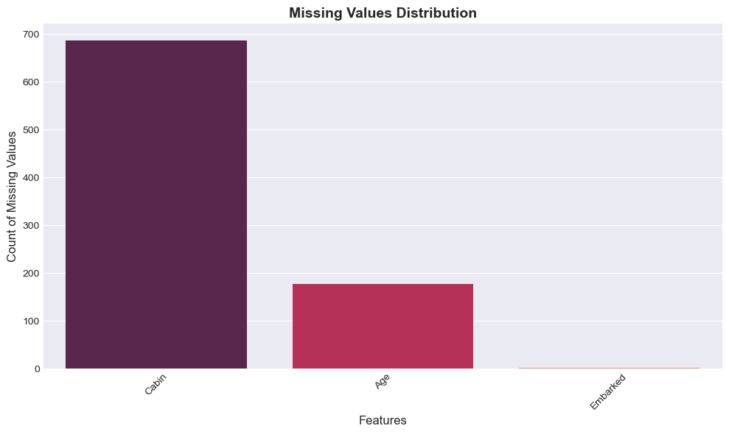
The distribution of values across different fields also varied. With Age showing a clear right-skewed distribution with most passengers between ages 20–40 (Note that several missing Age values were imputed using the median). Fares is another graph with a heavily skewed right, only a few passengers paid very high amounts (ex: 1st-class).
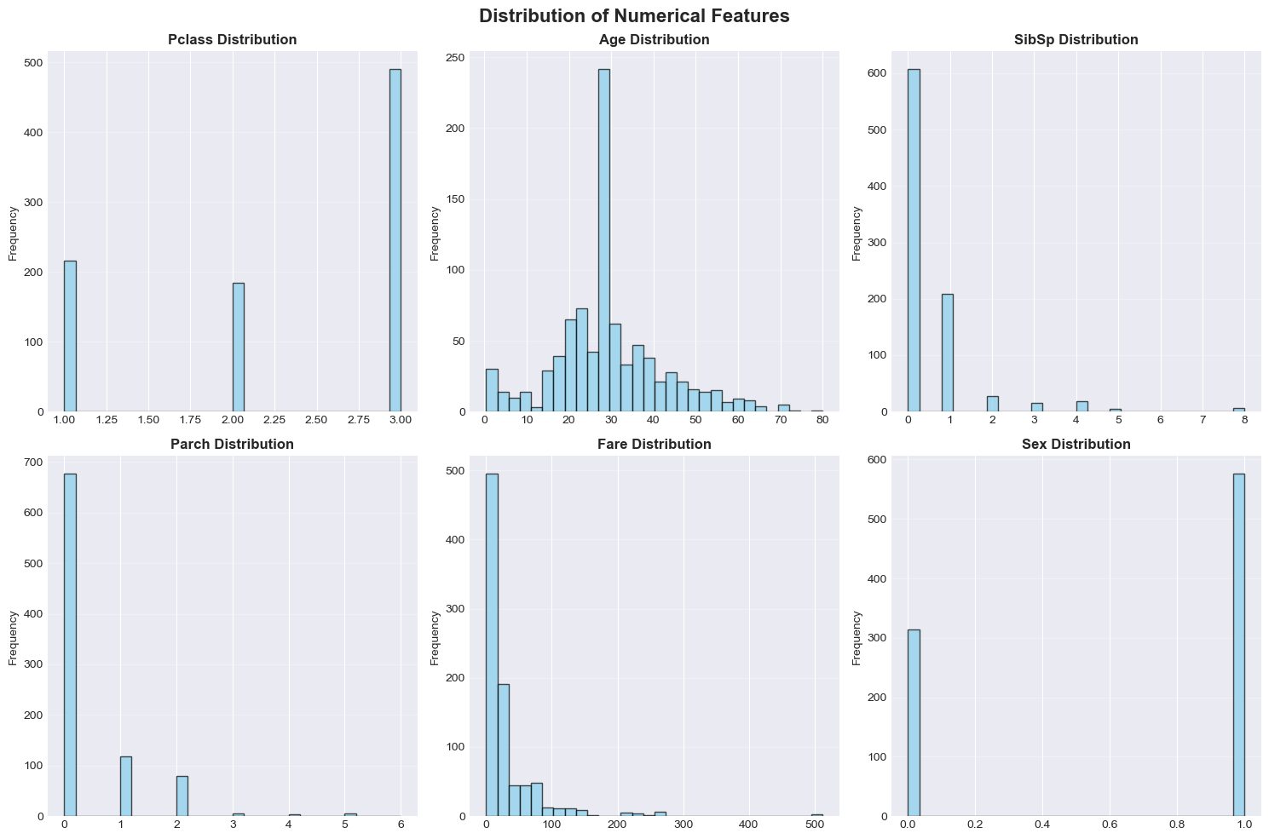
With 891 records, we can see the distribution of our target variable. Based on the Survived category, the number of people who Did Not Survive are 549 (61.6%) and those who Survived are 342 (38.4%). Survival Rate also has key connections/correlations between certain features in the dataset. Females have a dramatically higher survival rate (~74%) compared to males (~19%), which constitutes why this variable has the strongest predictive power in our models. It is also keen to note that First-class passengers have the highest survival rate (~63%), third-class the lowest (~24%).
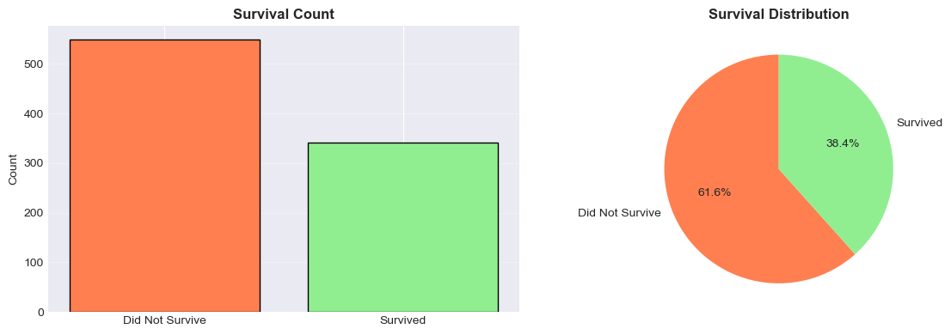
Here is the distribution of features in relation to their survival.
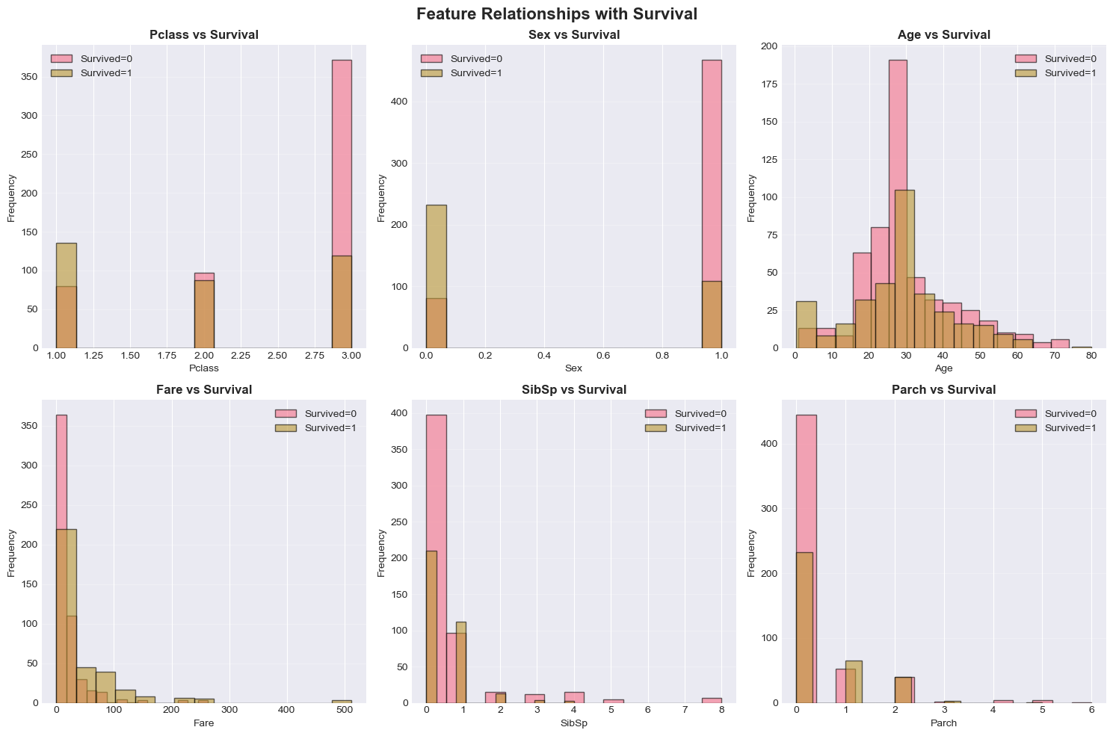
The feature correlation matrix also helps us to understand relationships between each feature better. As denoted by the histograms earlier, you can see a clear relationship between pclass, sex and fare to the target variable.
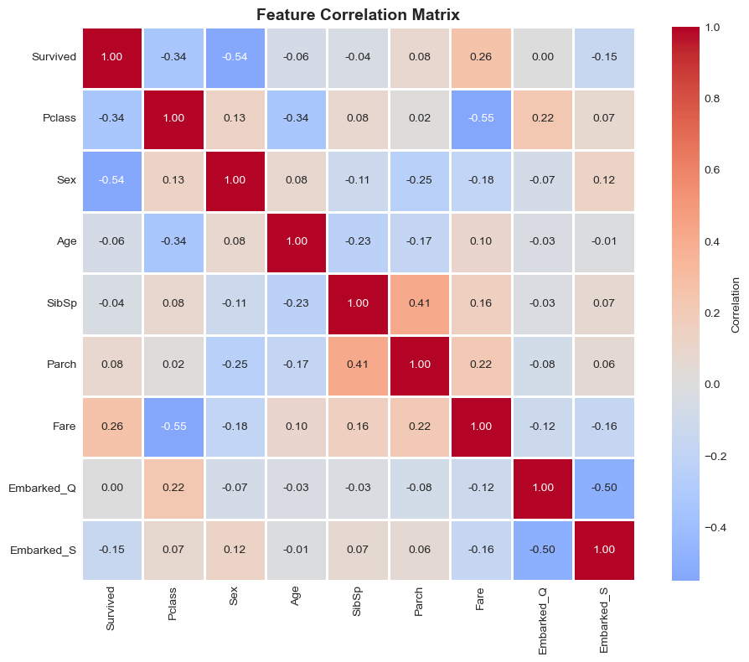
We also rank our important features for use in the 4 different classification models (based on decision tree importance).
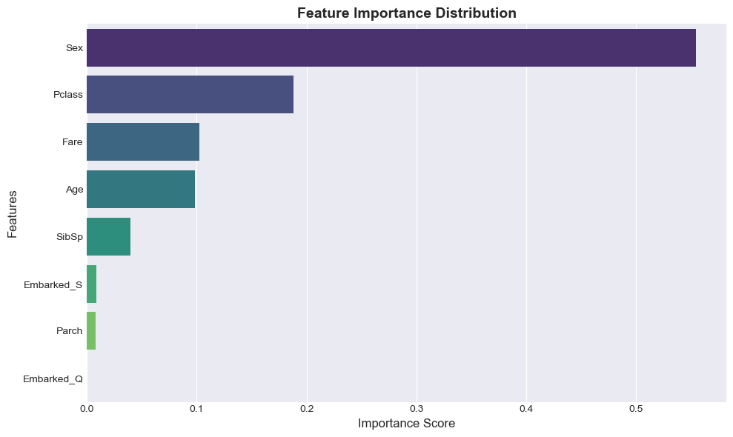

Models and hyperparameter tuning
- Decision Tree — baseline interpretable model; grid search over max_depth, min_samples_split, criterion, and min_sample_leaf.
- Random Forest — ensemble of trees; grid search over n_estimators, max_depth, max_features, min_samples_leaf, and min_samples_split.
- AdaBoost — boosting of weak learners (decision stumps/trees); grid search over n_estimators, learning_rate, and estimator_max_depth.
- XGBoost — gradient boosting implementation; grid search over n_estimators, max_depth, learning_rate, and subsample.
All models were tuned using GridSearchCV with ROC-AUC as the scoring metric for hyperparameter selection.

Model Development
1. Decision Tree

- Training Accuracy: 0.8244
- Test Accuracy: 0.7877
- Test Precision: 0.7627
- Test Recall: 0.6522
- Test F1-Score: 0.7031
- Test ROC-AUC: 0.8177

The Decision Tree classifier provides a rule-based segmentation of the Titanic dataset. However, this model tends to overfit the training data, which is evident from its higher training accuracy compared to the test set performance. Despite it, its generalization is limited because a single decision path can be highly sensitive to small changes in the input data.
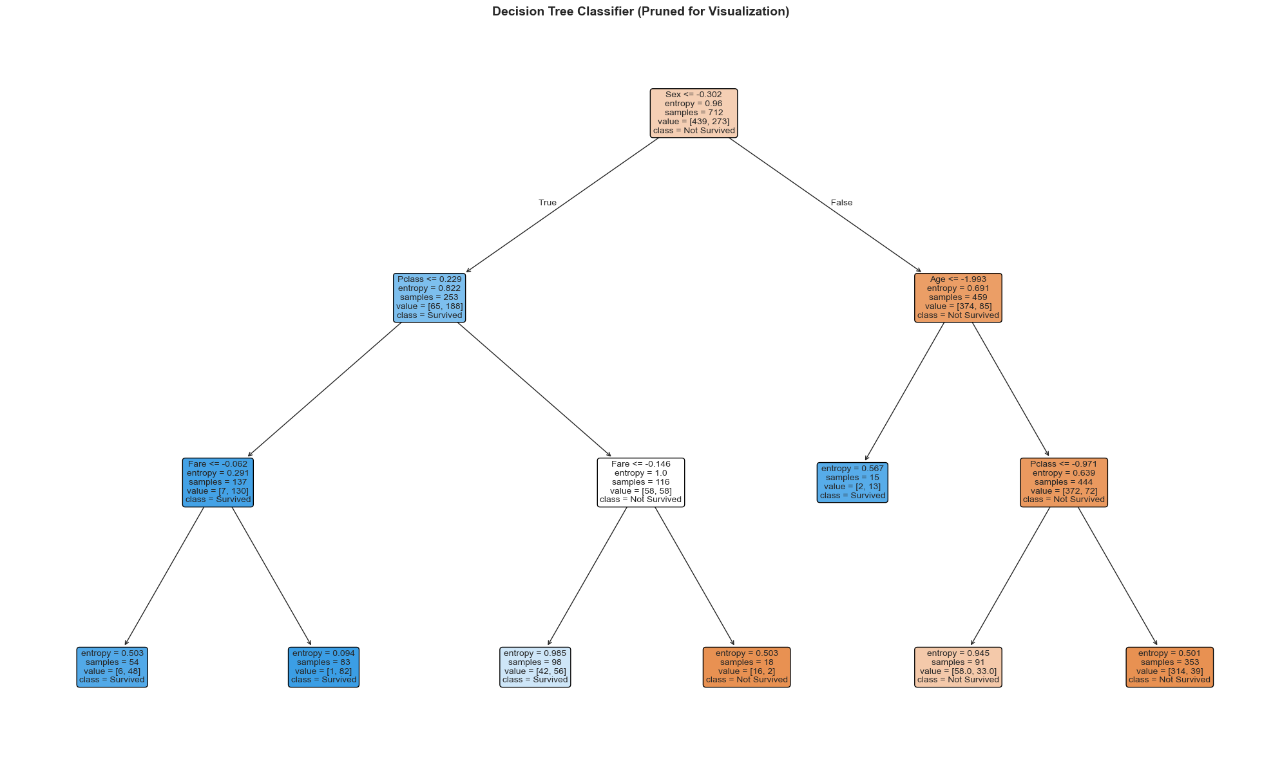
The most important features identified by the Decision Tree model are Sex, Fare, and Pclass, which align well with how survivability vs different features were understood. It showed that female passengers and those in higher classes had better survival odds. The tree also assigns moderate importance to Age and Embarked.
2. Random Forest

- Train_Accuracy: 0.8890
- Test_Accuracy: 0.8101
- Precision: 0.8302
- Recall: 0.6377
- F1_Score: 0.7213
- ROC_AUC: 0.8368

The Random Forest classifier improves upon the Decision Tree by constructing an ensemble of many trees, each trained on a random subset of features and samples. This aggregation reduces overfitting and variance, leading to a stronger overall performance.
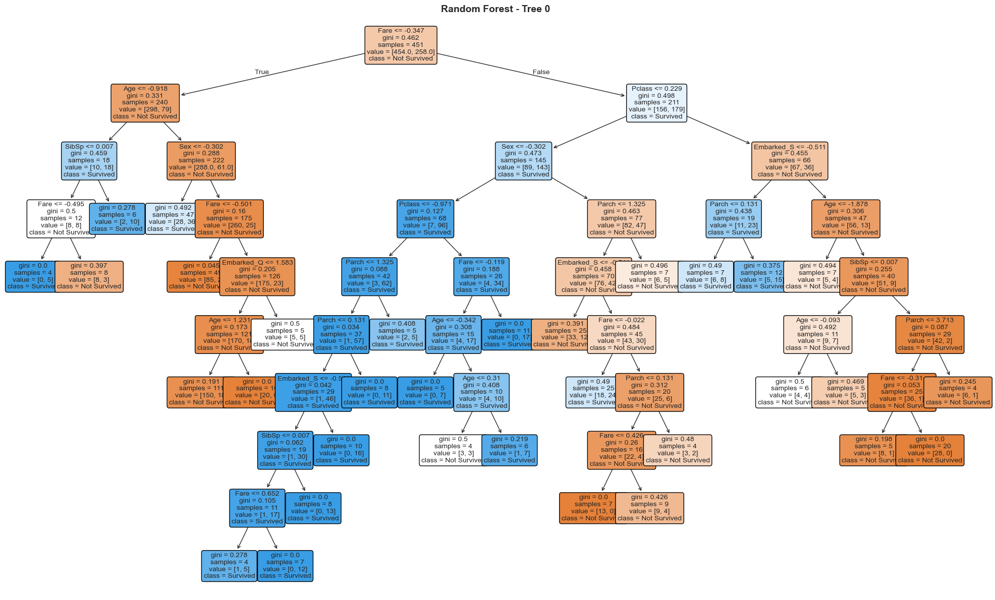
While the graph is messy, it highlights RF’s feature importances through a clear and consistent ranking, with Sex and Pclass remaining dominant predictors, followed by Fare and Age. However, the ensembling of the model results in a more stable distribution of importance weights, and prevents a single feature from dictating the decision process entirely.
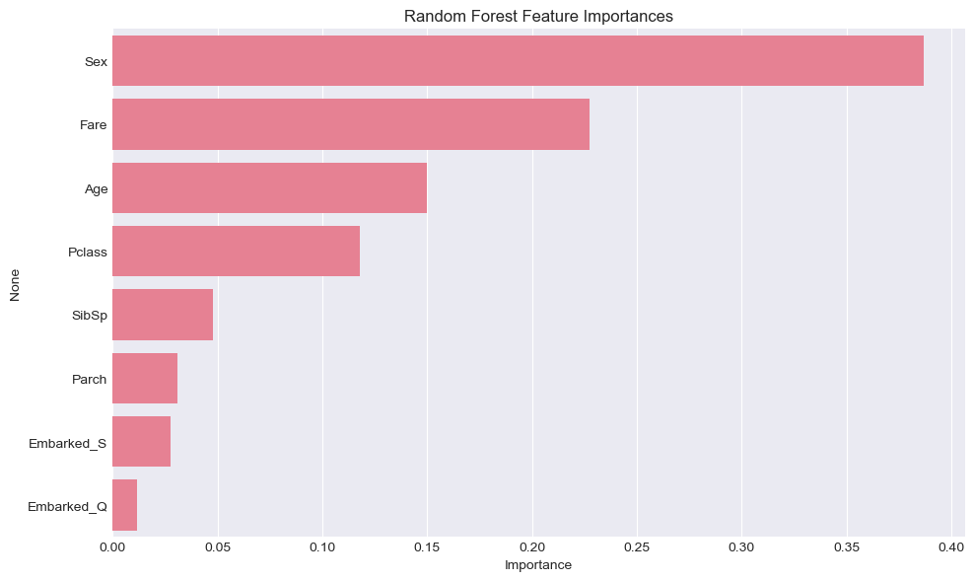
3. AdaBoost

- Train_Accuracy: 0.8778
- Test_Accuracy: 0.7933
- Precision: 0.7667
- Recall: 0.6667
- F1_Score: 0.7132
- ROC_AUC: 0.7945

AdaBoost demonstrated improved recall over Random Forest and Decision Tree, suggesting that its iterative nature with its weighting scheme effectively learns from harder instances. However, its precision and F1-score remained slightly lower than XGBoost.
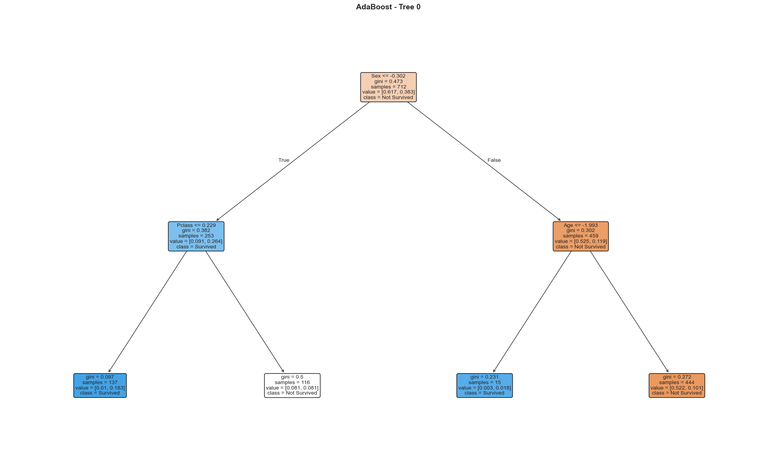
The model’s feature importances confirm that Sex and Pclass are still the leading contributors, but AdaBoost also gives moderate weight to Fare and Age, likely due to their boosting’s influence in latter boosting iterations.
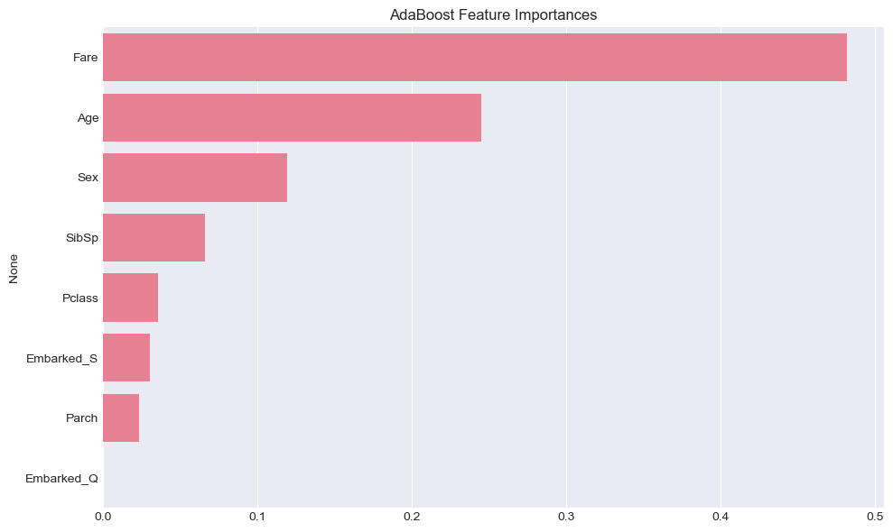
4. XGBoost

- Train_Accuracy: 0.9129
- Test_Accuracy: 0.7877
- Precision: 0.7541
- Recall: 0.6667
- F1_Score: 0.7077
- ROC_AUC: 0.8041

The XGBoost model delivered the best overall results in this project, achieving the highest cross-validated ROC-AUC and strong precision-recall balance (shown in graphs later). Its superiority reflects in both its fine-grained learning process and built-in handling of bias–variance trade-offs, which helped with its decision making. Note this tree graph, comes from the graphviz library compared to the sklearn tree graphs from the previous models because of issues implementing using the prior.
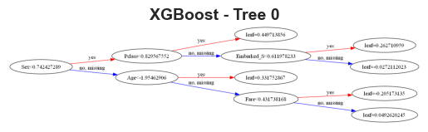
The feature importance analysis reinforces similar findings but with a slight difference. In this case, Sex remains dominant, while Pclass and Fare follow closely. It also shows that Age has a more significant weight than in Random Forest. The importance of the feature visualization below clearly shows that survival probabilities are influenced by a mixture of socioeconomic and demographic features.
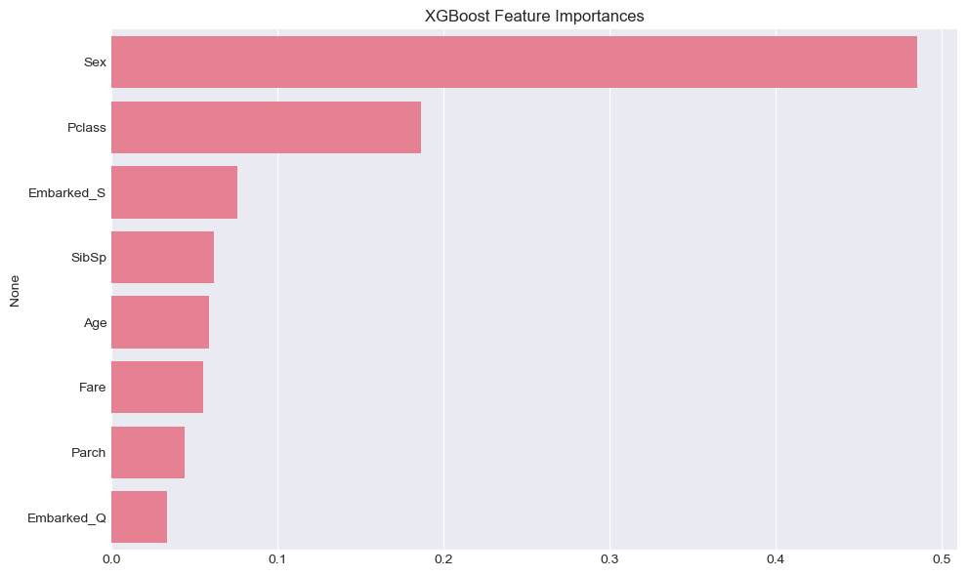
Confusion Matrix
Each model’s confusion matrix offered a detailed view of classification outcomes beyond overall accuracy. The Decision Tree tends to overpredict the majority class, yielding more false negatives. Random Forest mitigates this issue, producing a more balanced matrix with higher true positive counts and fewer misclassifications. AdaBoost further improves recall, correctly identifying more survivors but at the cost of slightly more false positives. Lastly, XGBoost achieves the most desirable balance with both false positives and false negatives minimized.
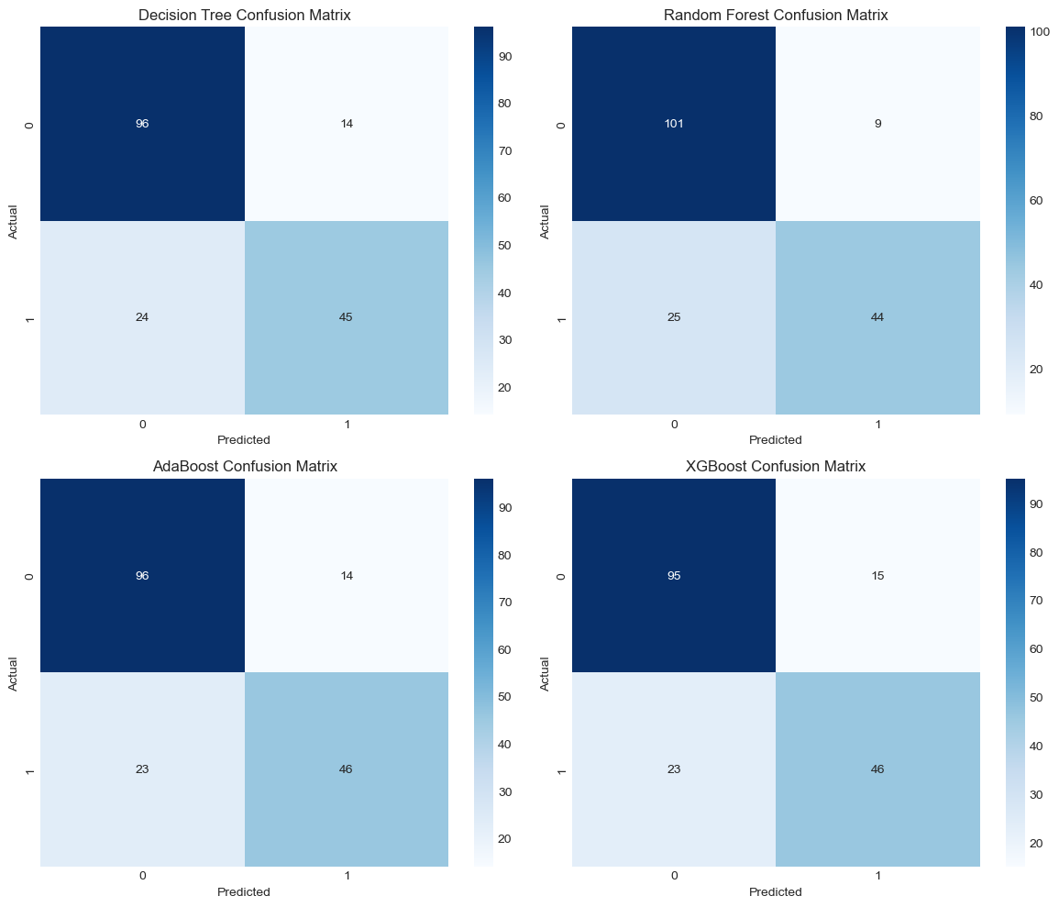
ROC-AUC and Precision-Recall Curves
The ROC curves illustrate the models’ ability to distinguish between survivors and non-survivors across different thresholds. The AdaBoost curve remains closest to the diagonal (lowest AUC), showing weaker discrimination. Random Forest and Decsion Trees shift the curve upward, indicating better sensitivity. The XGBoost ROC curve, however, consistently dominates the with a higher AUC over others.
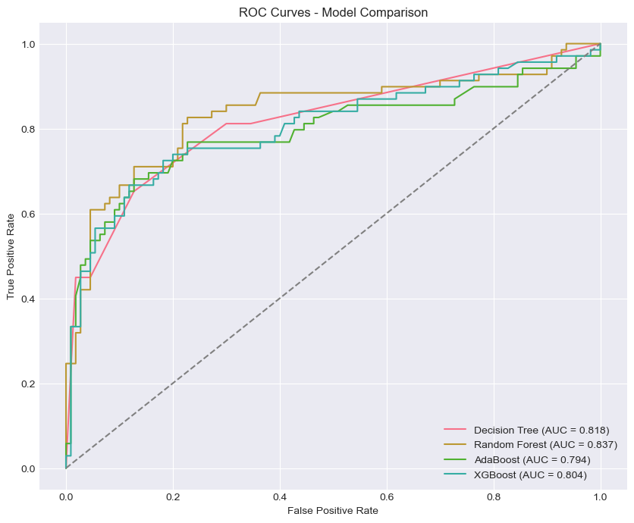
Precision–Recall curves provide further insight into this dataset, especially since survival is the minority class.
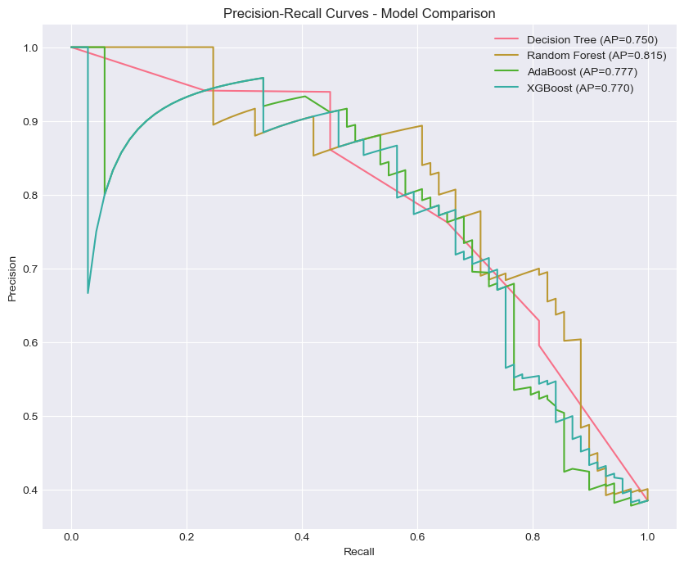
Conclusions
Across all evaluation metrics (accuracy, precision, recall, F1-score, and ROC-AUC), XGBoost consistently outperforms the other models. Random Forest follows closely as a strong second, while AdaBoost performs decent in contexts that require recalls. The Decision Tree model underperforms due to overfitting easily among other issues.
While all models on average have an + 85% ROC-AUC score after a 5-fold Cross-Validation, XGBoost still performs with the highest score in all other metrics. Therefore, XGBoost is the recommended model for this Titanic survival prediction task, offering the most accurate results.

